Sara Popow

Trig River

Summary:
Students learn about and use a right triangle to determine the width of a "pretend" river. Working in teams, they estimate of the width of the river, measure it and compare their results with classmates.

Standards:
Mathematical Practices
1. Make sense of problems and persevere in solving them.
2. Reason abstractly and quantitatively.
4. Model with mathematics.
5. Use appropriate tools strategically.
6. Attend to precision.
7. Look for and make use of structure
Similarity, Right Triangles, & Trigonometry G-SRT
Define trigonometric ratios and solve problems involving right triangles
6. Understand that by similarity, side ratios in right triangles are properties of the angles in the triangle, leading to definitions of trigonometric ratios for acute angles.
8. Use trigonometric ratios and the Pythagorean Theorem to solve right triangles in applied problems.

Learning Goals:
After this activity, students should be able to:
-Use right triangle trigonometry and angle measurements to calculate distances
-Perform averaging and comparison of numbers
-Explain how to use trigonometry and other mathematical relationships to estimate distances

Materials List:
-Trig River Packer
-Protractor (or printed copy of the attached Paper Half Protractor)
-Pipe Cleaner
-Pencil
-Tape measure or meter stick (groups can share)

Introduction:
‘Is it possible to determine the width of a river without crossing it?’
Answer: It is possible to come very close to determining the width of a river of any size, using triangles.
‘The same principle used to determine the width of a river can be applied to other situations, including determining the height of a hill, a tree or a building. The simple geometric shape that makes this all possible is the triangle. During this activity, you will learn how to use triangles to determine the width of a river.’

Setup:
- Define a ‘river area’ for students. Outside could be two ‘banks’, inside could be two rows of desks.
- On one side of the river (as close to the middle of that side as possible, set an object that will be the Far Edge Marker. Normally this represents a tree right at the edge of the opposite side of the river.
- Directly across from the marker, place a Zero Edge Marker (see Figure 1). All the students should be on this side of the river.
- Lay the measuring tape along the "zero edge bank" with one end at the Zero Edge Marker and place a piece of tape every ½ meter on the river edge of the desks. Repeat this in the other direction (see Figure 1).

Procedure:
- Give each student a worksheet.
- Each student should make an estimate of how wide the river is and record it on the back of their worksheet (anywhere on the paper is acceptable).
- Each group will work from a different tape mark. When both students of a group are at their designated mark and have written on their worksheet the distance their tape is from the Zero Edge Marker, give each group a protractor.
- Lay the protractor with the center point on the middle of the tape and the zero angle pointing toward the Zero Edge Marker (see below).
- One student will hold the protractor in place while the other places one end of the string on the center point of the protractor and aims the other end at the Far Edge Marker. Read the angle the string passes over on the protractor (counting up from zero; this should not be more than 90 degrees), and record it on the worksheet. While the students do this, the teacher can measure the actual distance between the two markers; do not reveal the distance yet.
- Partners switch jobs and record a second measurement on their worksheet.
- Complete the worksheet calculations. (Leave the desks and markers in place.)

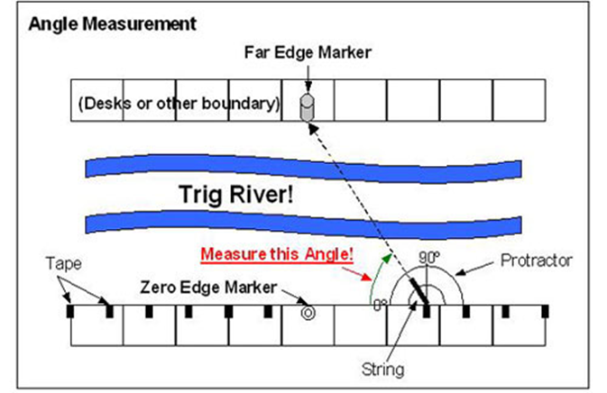

Closing:
- Were students closer to the zero marker more or less accurate than those further away? (Answer: Students close to the zero marker should be less accurate because the values of the tangents of angles close to 90º become large quickly and a small error in the angle measurement results in a large distance error. Note that the same problem would be seen as the measured angle approached zero degrees, but a student would have to be infinitely far away for that.)
- Could this method be used in the wilderness if you did not have a calculator or Trig Tables? (Answer: It is not easy to memorize the tangent values for all angles but one value is very easy to remember: tan(45). Have the students find this value and then explain why they get a simple answer.)

Source: https://www.teachengineering.org/view_activity.php?url=collection/cub_/activities/cub_navigation/cub_navigation_lesson03_activity2.xml

