Name: ______________________________ Date: ______________
Trig River
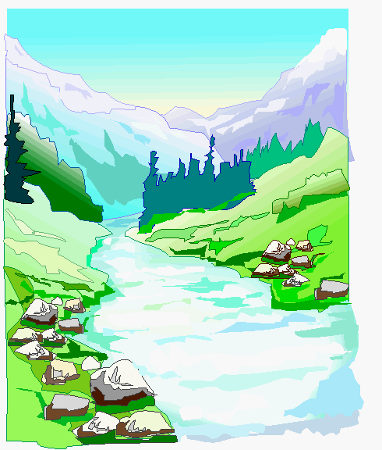
Your Estimate: _________________________

Your Answer: __________________________

Actual Distance: ________________________

% Error of Answer and Actual Distance:

Is this an accurate method for measuring the width of a river? __________ Why or why not?
__________________________________________________________________________________________________________________________________________________________________________________________________________________________________________________________________________________________________________________________________

